Service |  |  |  | High Availability and Disaster Recovery
System |  |  |  | Cluster and DR servers
Department |  |  |  | Information Technology
# | Version Type: |  | Author: |  | Version Date:
1.0 | Original Document |  | Akshay |  | 4-Aug-2024
Purpose:
This is the Standard Operating Procedure to setup LogShipping between Cluster servers and the respective DR servers.
Scope:
This document involves the below systems and all the databases hosted over these servers are part of High Availability and Disaster Recovery
Cluster Name | DR Server
CP02P-DSSV1 | EP02P-DVMSQL01.sunwing.local
CP02P-DSSV2 | EP02P-DVMSQL02.sunwing.local
CSAP01P-DSSV1 | ESAP01-DVMSQL03.sunwing.local
Setting Up Log Shipping in SQL Server with PowerShell Automation using dbatools
This guide will provide step-by-step instructions on how to set up log shipping in SQL Server using the PowerShell automation tool, dbatools. The script uses the Invoke-DbaDbLogShipping cmdlet with various parameters to configure and manage log shipping between a source and destination SQL Server instance.
Prerequisites
- PowerShell: Ensure we have PowerShell installed on respective servers.
- dbatools Module: Install the dbatools PowerShell module, if not installed using below command.
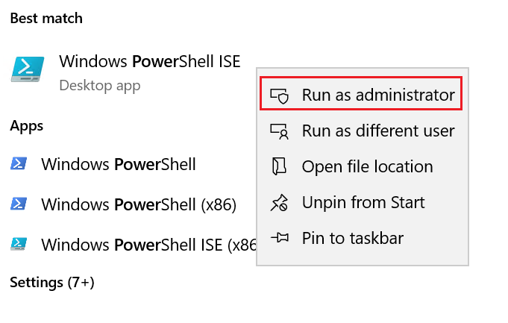
Install-Module dbatools
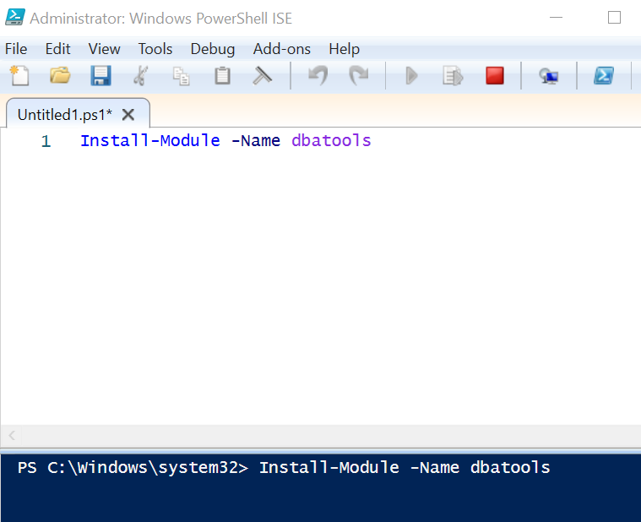
- Permissions: Ensure that we have Sysadmin permissions to configure log shipping on both the source and destination SQL Server instances.
- ADM_DBA members should have Read/Write access to premium file share
- Network Share: Ensure that the shared path is accessible from both the source and destination servers.
- Ensure that the SQL Server service account has “Storage File Data SMB Share Elevated Contributor role for premium file share” RBAC role.
Steps to Set Up Log Shipping
1. Define the Parameters
First, define the parameters required for the log shipping configuration. These parameters include details of the source and destination SQL Server instances, database names, schedule frequencies, backup options, and other necessary settings.
$params = @{
SourceSqlInstance = 'Name of the source server'
DestinationSqlInstance = 'Name of the target server'
Database = <Database Names separated by commas>
SharedPath = '\\cp02pdsacl1n001.file.core.windows.net\cp02p- dfscl1n001\LOG_SHIPPING\SharedCluster-LShipping\LS_Backups'
BackupScheduleFrequencyType = 'daily'
BackupScheduleFrequencyInterval = 1
BackupThreshold = 45
CompressBackup = $true
CopyScheduleFrequencyType = 'daily'
CopyScheduleFrequencyInterval = 1
GenerateFullBackup = $true
RestoreScheduleFrequencyType = 'daily'
RestoreScheduleFrequencyInterval = 1
RestoreThreshold = 45
RestoreAlertThreshold = 45
CopyDestinationFolder = 'Destination folder'
DisconnectUsers = $true
Standby = $true
StandbyDirectory = 'Standby folder'
Force = $true
}
3. Invoke the Log Shipping Setup
Use the Invoke-DbaDbLogShipping cmdlet with the defined parameters to set up log shipping.
Invoke-DbaDbLogShipping @params
Detailed Explanation of Parameters
- SourceSqlInstance: The name of the SQL Server instance from which the backups will be taken.
- DestinationSqlInstance: The name of the SQL Server instance where the backups will be restored.
- Database: The databases to be included in log shipping. Multiple database names should be separated by commas.
- SharedPath: The network path where the backup files will be stored.
- BackupScheduleFrequencyType: The frequency type for the backup schedule (e.g., daily, hourly).
- BackupScheduleFrequencyInterval: The interval for the backup schedule.
- BackupThreshold: The maximum allowed time (in minutes) since the last backup before an alert is raised.
- CompressBackup: Boolean value to specify if the backup should be compressed.
- CopyScheduleFrequencyType: The frequency type for the copy schedule.
- CopyScheduleFrequencyInterval: The interval for the copy schedule.
- GenerateFullBackup: Boolean value to specify if a full backup should be generated initially.
- RestoreScheduleFrequencyType: The frequency type for the restore schedule.
- RestoreScheduleFrequencyInterval: The interval for the restore schedule.
- RestoreThreshold: The maximum allowed time (in minutes) since the last restore before an alert is raised.
- RestoreAlertThreshold: The maximum allowed time (in minutes) since the last restore before an alert is raised.
- CopyDestinationFolder: The folder on the destination server where the copied log backups will be stored.
- DisconnectUsers: Boolean value to specify if users should be disconnected during restore operations.
- Standby: Boolean value to specify if the database should be left in standby mode.
- StandbyDirectory: The directory where the standby files will be stored.
- Force: Boolean value to force the operation.
Login to the server which is currently active in the cluster. We can use the query to find out which node is active.
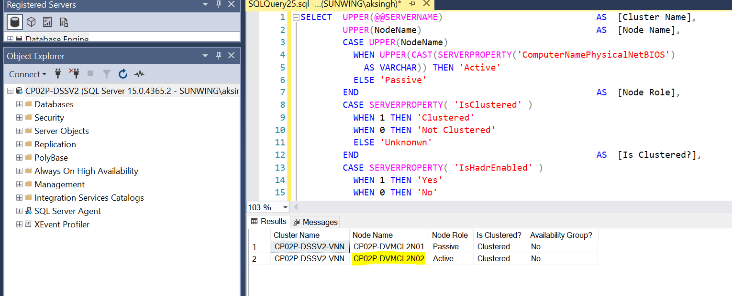
Launch the PowerShell console and edit the script as per the use case. We can include one database or more than one database. Execute the script once it is ready.
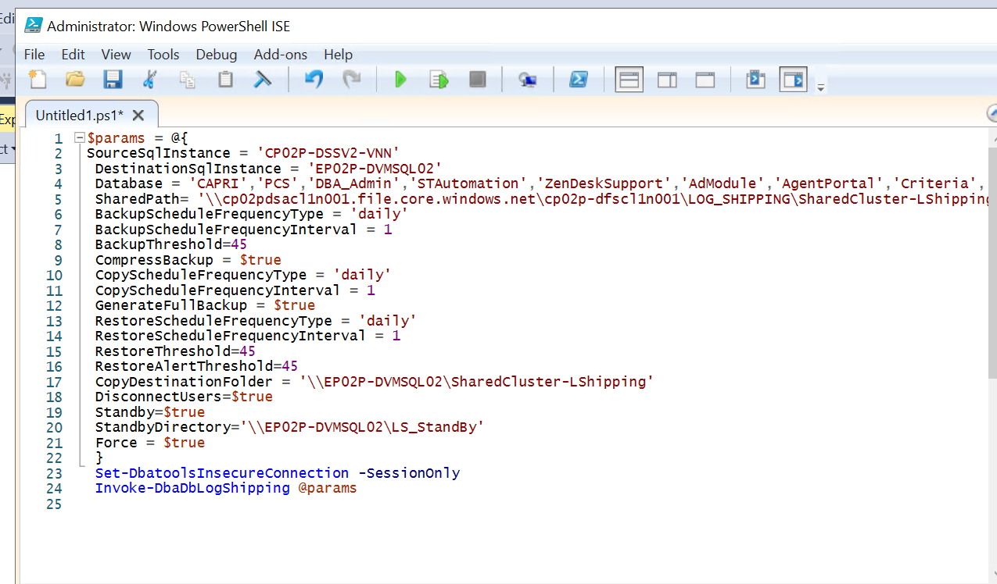
Conclusion
By following these steps, we can automate the setup of log shipping in SQL Server using PowerShell. Ensure that all parameters are correctly defined and that the necessary permissions and network paths are in place for a successful configuration.

Recovering Databases on the DR server:
1. Prerequisites
Before starting the recovery process, ensure the following prerequisites are met:
- PowerShell is installed on the machine where the commands will be run.
- The dbatools PowerShell module is installed. If not, we can install it using the following command:
Install-Module -Name dbatools
- The DR server is properly configured for remote connections and is accessible from the primary.
Make sure we have firewall rule enabled for port 1433 from Cluster server to DR.
- ADM_DBA members should have Read/Write access to premium file share
- SQL Service account must have Storage File Data SMB Share Elevated Contributor role access on the premium file share to execute backups from SQL Server.
2. Preparing the Environment
2.1. Open PowerShell with Administrator Privileges
2.2. Load the dbatools Module
Import-Module dbatools
3. Set Insecure Connection
To allow an insecure connection for the current session only:
Set-DbatoolsInsecureConnection -SessionOnly (Optional)
4. Invoke Database Log Shipping Recovery
Use the Invoke-DbaDbLogShipRecovery cmdlet to recover the databases. Replace <Servername> and <DBName> with the appropriate values.
Invoking this command will execute the copy job for the respective database, then restore job would be executed and followed by restore command WITH RECOVERY will be executed (all this happens in the background).
4.1. Example Command
Invoke-DbaDbLogShipRecovery -SqlInstance DRServer -Database MyDatabase -Verbose
5. Detailed Steps for the Recovery Process
5.1. Open PowerShell and Set Up Environment
- Open PowerShell as Administrator.

- Load the dbatools module.
5.2. Execute the Recovery Command
- Run the Invoke-DbaDbLogShipRecovery cmdlet with the necessary parameters.
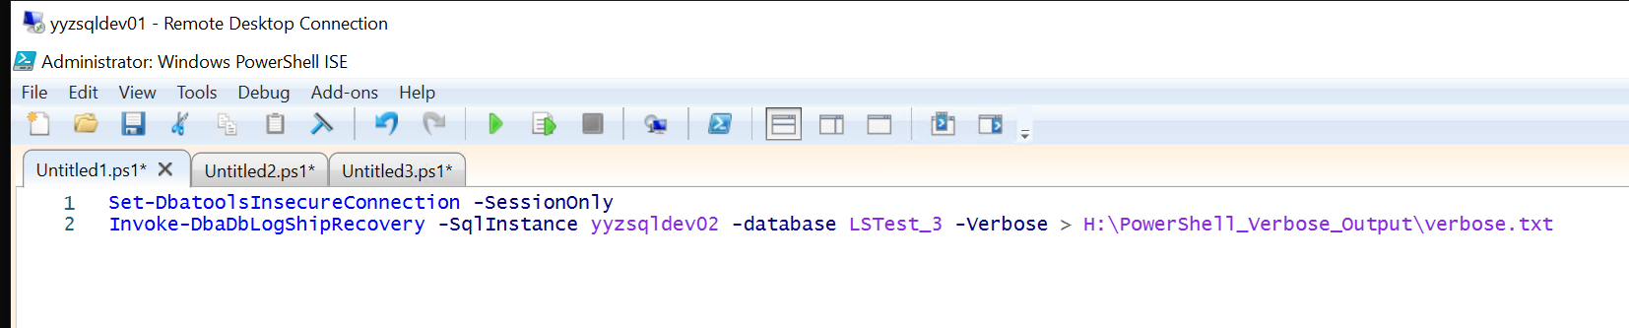
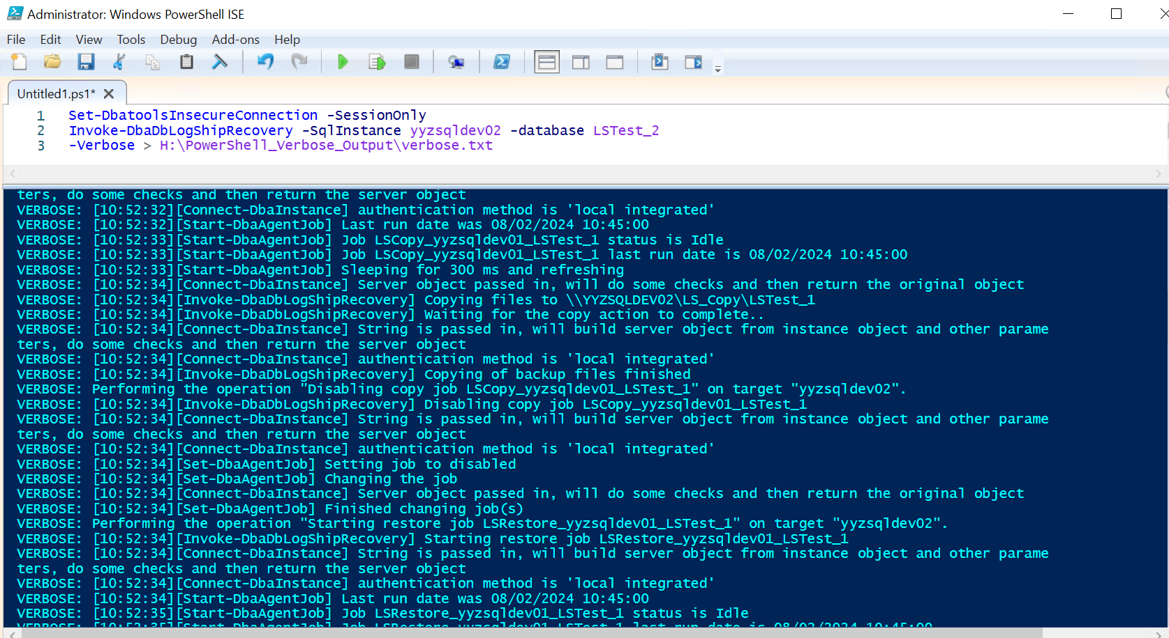
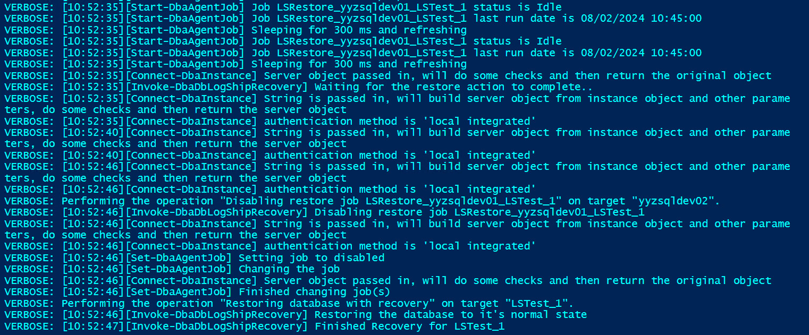

6. Monitoring and Logging
6.1. Monitor the Recovery Process
- The -Verbose parameter will provide detailed output.

